FGS-2706B Network Interface Device (NID)

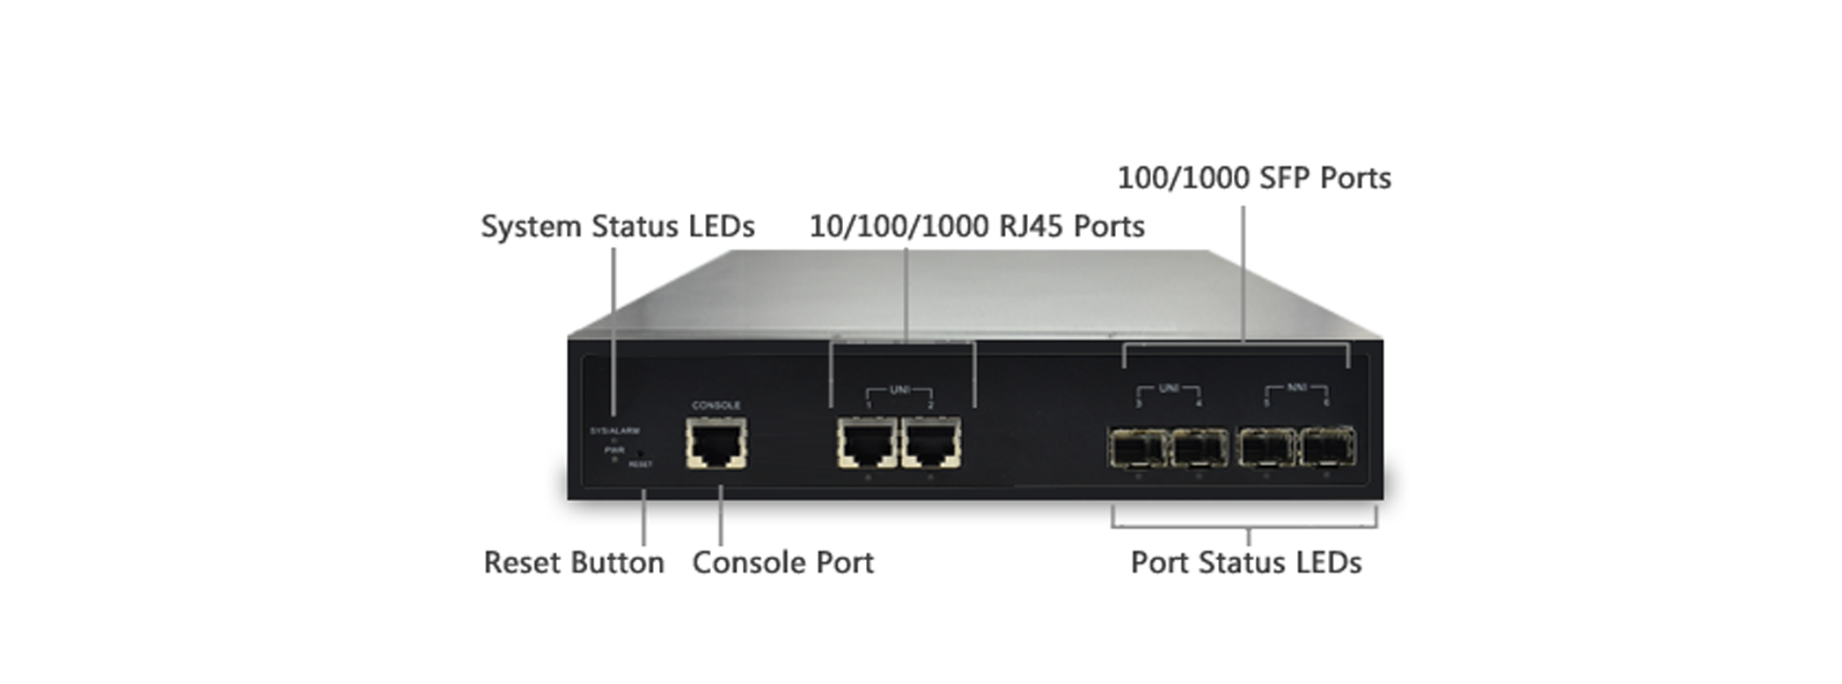
Overview
FGS-2706B L2+ Managed Switch is a next-generation Carrier Ethernet Switch offering full suite of L2 features, L3 Static Route and Carrier Ethernet features such as OAM, CFM and 1588v2 PTP, etc, which delivers better cost performance and lower total cost of ownership in Enterprise networks via fiber or copper connections.
FGS-2706B delivers 2 (10M/100M/1G) RJ45 ports, 4 GbE SFP ports, RJ45 Console port with built-in AC only (Standard), DC only (By request) or AC/DC dual (By request); three types of power supply for option. FGS-2706B provides front access to all data and management ports, and a compact form factor that facilitates wall-mount, or rack-mount installations for Carrier/Telecom providers.
FGS-2706B is ideal for environments that require advanced features for granular control which is a must for easy network configuration and management where you need for a successful installation for converged video voice and data networks in Carrier Ethernet Applications.
Key Features
- Carrier features provide easier manageability, security and QoS
- IEEE 1588v2 PTP (TC)
- IEEE 802.3ah OAM
- IEEE 802.1ag CFM (ITU-T Y.1731 Performance monitoring)
- ITU-T Y.1564 (RFC2544) Ethernet Service Activation Test
- ITU-T G.8031 Ethernet Linear Protection Switching (EPS)
- ITU-T G.8032 Ethernet Ring Protection Switching (ERPS)
- RFC2544
- Y.1564
- DHCP Server
- IPv4/IPv6 L3 static route
- IEEE 802.3az Energy Efficient Ethernet standard for green Ethernet application
Benefits
- Feature-rich Carrier Ethernet Switch for Metro Ethernet
The switch delivers advanced functionality in Carrier Ethernet switch including IEEE 1588v2, OAM, CFM, etc. It also enhanced security features such as IP source guard, Access Control List guard your network from unwanted or unauthorized access.
It helps users to build on the market-leading price/performance with Carrier Ethernet switch, and provide secure, reliable for metro Ethernet deployments.

- Exceptional Precision with IEEE 1588v2 (TC)
The NID performs IEEE1588v2 with transparent clock capability, implementations in hardware, so there is no performance penalty on packet processing.
The hardware architecture ensures low latency and high time accuracy – which is critical for delay-sensitive financial and mobile applications.

- Superior reliability through OAM and CFM for Service Assurance
Service assurance is provided through a rich feature set of operations, administration, and maintenance (OAM) functionalities. It can simplify and facilitate the management of Carrier network, resulting in diminishing operational costs.
The Ethernet access device also offers standards-based fault and performance management in adherence with 1731 PM and 802.1ag connectivity fault management (CFM) standards. It comes with RFC 2544 and Y.1564 that include both generation and reflection of traffic.
These features contribute to significant reduction in operational expenditures and allows for troubleshooting without expensive truck rolls.

- Lower Total Cost of Ownership (TCO) with Energy-efficient Design
The switch is designed to help companies to save power needs and reduce TCO by Energy Efficient Ethernet (IEEE 802.3az). It can be used for customers to build a green Ethernet networking environment.

Specifications
Port Configuration
Total Ports | RJ45 (10M/100M/1G) | SFP (100M/1G) | Console Port
6 | 2 | 4 | RJ45

Hardware Performance
Forwarding Capacity | Switching Capacity | Mac Table | Jumbo Frames
8.928 Mpps | 12 Gbps | 8 K | 9216 Bytes

Environmental Range
Mode | Operating Temperature |  | Storage Temperature |  | Altitude
Mode | Fahrenheit | Centigrade | Fahrenheit | Centigrade | Feet | Meters
AC(Standard) | -40 to122 | 0 to 50 | -40 to 176 | -40 to 80 | < 10000 | < 3000
DC(By request) | -40 to 149 | -40 to 65 | -40 to 176 | -40 to 80 | < 10000 | < 3000
AC/DC Dual(By request) | -40 to 149 | -40 to 65 | -40 to 176 | -40 to 80 | < 10000 | < 3000

Dimension, Weights, Humidity
Dimension (WxHxD) |  |  | Weight |  |  | Operating Humidity
Millimeter | Inches |  | Kilograms | Pounds |  | Operating Humidity
220 x 44 x 130.5 | 8.7 x 1.73 x 5.14 | 1.0 |  |  | 2.2 | 10% to 90% non-condensing

Voltage and Frequency
Input Voltage and Frequency
AC Voltage | 100-240 VAC
AC Frequency | 50-60 Hz
DC Voltage(By request) | 24-48 VDC

Certification
Electromagnetic Emissions (EMC)
CE, FCC Part 15 Class A
Software Features
Layer 2 Switching
Spanning Tree Protocol (STP) | - Standard Spanning Tree 802.1d  - Rapid Spanning Tree (RSTP) 802.1w  - Multiple Spanning Tree (MSTP) 802.1s
Trunking | Link Aggregation Control Protocol (LACP) IEEE 802.3ad
VLAN | Supports up to 4K VLANs simultaneously (out of 4096 VLAN IDs)  - Port-based VLAN  - 802.1Q tag-based VLAN  - MAC-based VLAN  - Management VLAN  - Private VLAN Edge (PVE)  - Q-in-Q (double tag) VLAN  - Voice VLAN  - GARP VLAN Registration Protocol (GVRP)
DHCP Relay | - Relay of DHCP traffic to DHCP server in different VLAN.  - Works with DHCP Option 82
IGMP v1/v2/v3 Snooping | IGMP limits bandwidth-intensive multicast traffic to only the requesters. Supports 1024 multicast groups
IGMP Querier | IGMP querier is used to support a Layer 2 multicast domain of snooping switches in the absence of a multicast router
IGMP Proxy | IGMP snooping with proxy reporting or report suppression actively filters IGMP packets in order to reduce load on the multicast router
MLD v1/v2 Snooping | Delivers IPv6 multicast packets only to the required receivers
Layer 3 Switching
IPv4 Static routing | IPv4 Unicast: Static routing
IPv6 Static routing | IPv6 Unicast: Static routing
Security
Secure Shell (SSH) | SSH secures Telnet traffic in or out of the switch, SSH v1 and v2 are supported
Secure Sockets Layer (SSL) | SSL encrypts the http traffic, allowing advanced secure access to the browser-based management GUI in the switch
IEEE 802.1X | - IEEE802.1X: RADIUS authentication, authorization and accounting, MD5 hash, guest VLAN, single/multiple host mode and single/multiple sessions  - Supports IGMP-RADIUS based 802.1X  - Dynamic VLAN assignment
Layer 2 Isolation Private VLAN Edge | PVE (also known as protected ports) provides L2 isolation between clients in the same VLAN. Supports multiple uplinks
Port Security | Locks MAC addresses to ports, and limits the number of learned MAC address
Security
IP Source Guard | Prevents illegal IP address from accessing to specific port in the switch
RADIUS/ TACACS+ | Supports RADIUS and TACACS+ authentication. Switch as a client
Storm Control | Prevents traffic on a LAN from being disrupted by a broadcast, multicast, or unicast storm on a port
DHCP Snooping | A feature acts as a firewall between untrusted hosts and trusted DHCP servers
ACLs | Supports up to 256 entries. Drop or rate limitation based on:  - Source and destination MAC, VLAN ID or IP address, protocol, port,  - Differentiated services code point (DSCP) / IP precedence  - TCP/ UDP source and destination ports  - 802.1p priority  - Ethernet type  - Internet Control Message Protocol (ICMP) packets  - TCP flag
Quality of Service
Hardware Queue | Supports 8 hardware queues
Scheduling | - Strict priority and weighted round-robin (WRR)  - Queue assignment based on DSCP and class of service
Classification | - Port based  - 802.1p VLAN priority based  - IPv4/IPv6 precedence / DSCP based  - Differentiated Services (DiffServ)  - Classification and re-marking ACLs
Rate Limiting | - Ingress policer  - Egress shaping and rate control  - Per port
Management
IEEE 1588v2 PTP | Support IEEE 1588 v2 PTP (Precision Time Protocol) TC aware
ITU-T Y.1564 | Support RFC2544 Ethernet Service Activation Test
DHCP Server | Support DHCP server to assign IP to DHCP clients
Remote Monitoring (RMON) | Embedded RMON agent supports RMON groups 1,2,3,9 (history, statistics, alarms, and events) for enhanced traffic management, monitoring and analysis
Port Mirroring | Traffic on a port can be mirrored to another port for analysis with a network analyzer or RMON probe. Up to N-1 (N is Switch’s Ports) ports can be mirrored to single destination port. A single session is supported.
UPnP | The Universal Plug and Play Forum, an industry group of companies working to enable device-to-device interoperability by promoting Universal Plug and Play

Management
s-Flow | The industry standard for monitoring high speed switched networks. It gives complete visibility into the use of networks enabling performance optimization, accounting/billing for usage, and defense against security threats
IEEE 802.1ab (LLDP) | - Used by network devices for advertising their identities, capabilities, and neighbors on an IEEE 802ab local area network  - Support LLDP-MED extensions
Web GUI Interface | Built-in switch configuration utility for browser-based device configuration
CLI | For users to configure/manage switches in command line modes
Dual Image | Independent primary and secondary images for backup while upgrading
SNMP | SNMP version1, 2c and 3 with support for traps, and SNMP version 3 user-based security model (USM)
Firmware Upgrade | - Web browser upgrade (HTTP/ HTTPs) and TFTP  - Upgrade through console port as well
NTP | Network Time Protocol (NTP) is a networking protocol for clock synchronization between computer systems over packet-switched
Other Management | - HTTP/HTTPs; SSH  - DHCP Client/ DHCPv6 Client  - Cable Diagnostics  - Ping  - Syslog  - Telnet  - IPv6 Management
Ethernet OAM
IEEE 802.3ah Link OAM | Supports IEEE 802.3ah Ethernet OAM (Operations, Administration & Management)
IEEE 802.1ag & ITU-T Y.1731 Flow OAM | - Supports IEEE 802.1ag Ethernet CFM (Connectivity Fault Management)  - Supports ITU-T Y.1731 Performance Monitoring
ITU-T Y.1564 | Support RFC2544 Ethernet Service Activation Test Benchmarking Methodology:  Throughput, Latency, Frame loss rate, Back-to-back frames Test
Loop Protection
ITU-T G.8031 | Supports ITU-T G.8031 Ethernet Linear Protection
ITU-T G.8032 | Supports ITU-T G.8032 Ethernet Ring Protection Switching
Loop Detection | Supports Loop Detection and Protection

