GS-5524 Unmanaged GbE Switch

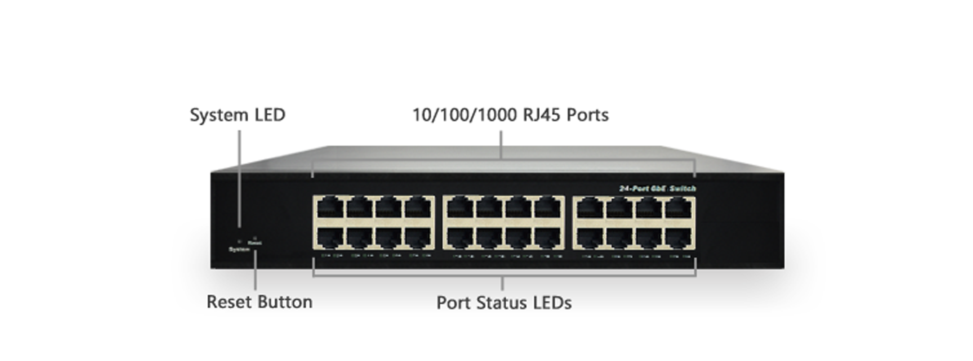

Overview
GS-5524 unmanaged GbE switch is a plug-and-play Ethernet switch offering easy way to make the transition to Gigabit Ethernet and increase the speed of your network connection. The energy efficient, built to last, and rigorously tested provide the reliability businesses need.
GS-5524 delivers 24 (10M/100M/1G) RJ45 ports. GS-5524 provides high HW performance and environment flexibility for SMBs and Enterprises.
Key Features
- IEEE 802.3u 100BASE-TX, 100Base-FX Fast Ethernet
- IEEE 802.3ab 1000Base-T Gigabit Ethernet
- IEEE 802.3z 1000Base-X Gigabit Fiber Ethernet
- IEEE 802.3az EEE Energy Efficient Ethernet standard for green Ethernet

Benefits

- Lowing Total Cost of Ownership (TCO) with Energy-efficient Design
The switch is designed to help companies to save power needs and reduce TCO by Energy Efficient Ethernet (IEEE 802.3az). It can be used for customers to build a green Ethernet networking environment.

Specifications
Port Configuration
Total Ports | RJ45 (10M/100M/1G) | Uplinks (100M/1G) | Console
24 | 24 | -- | --

Hardware Performance
Forwarding Capacity (Mpps) | Switching  Capacity (Gbps) | Mac Table  (K) | Jumbo Frames  (Bytes)
35.712 | 48 | 8 | 9216

Environmental Range
Operating Temperature |  | Storage Temperature |  | Operating Humidity | Altitude
Fahrenheit | Centigrade | Fahrenheit | Centigrade | 10% to 90% non-condensing | Feet | Meters
32 to 122 | 0 to 50 | -4 to 158 | -20 to 70 | 10% to 90% non-condensing | < 10000 | <3000

Dimension, Weights, Mounting
Dimension (WxHxD) |  |  |  | Weight |  |  |  | Mounting Type
Millimeter |  | Inches |  | Kilograms |  | Pounds |  | Mounting Type
280x 44x 166 | 11x 1.7x 6.5 |  | <2.5 |  | <5.5 |  | Desktop, Wall

Voltage and Frequency
AC Input Voltage and Frequency
Voltage | 100-240 VAC
Frequency | 50~60 Hz

Certifications
Electromagnetic Emissions (EMC)
CE, FCC Part 15 Class A

