PSGS-5524F Unmanaged GbE PoE+ Switch

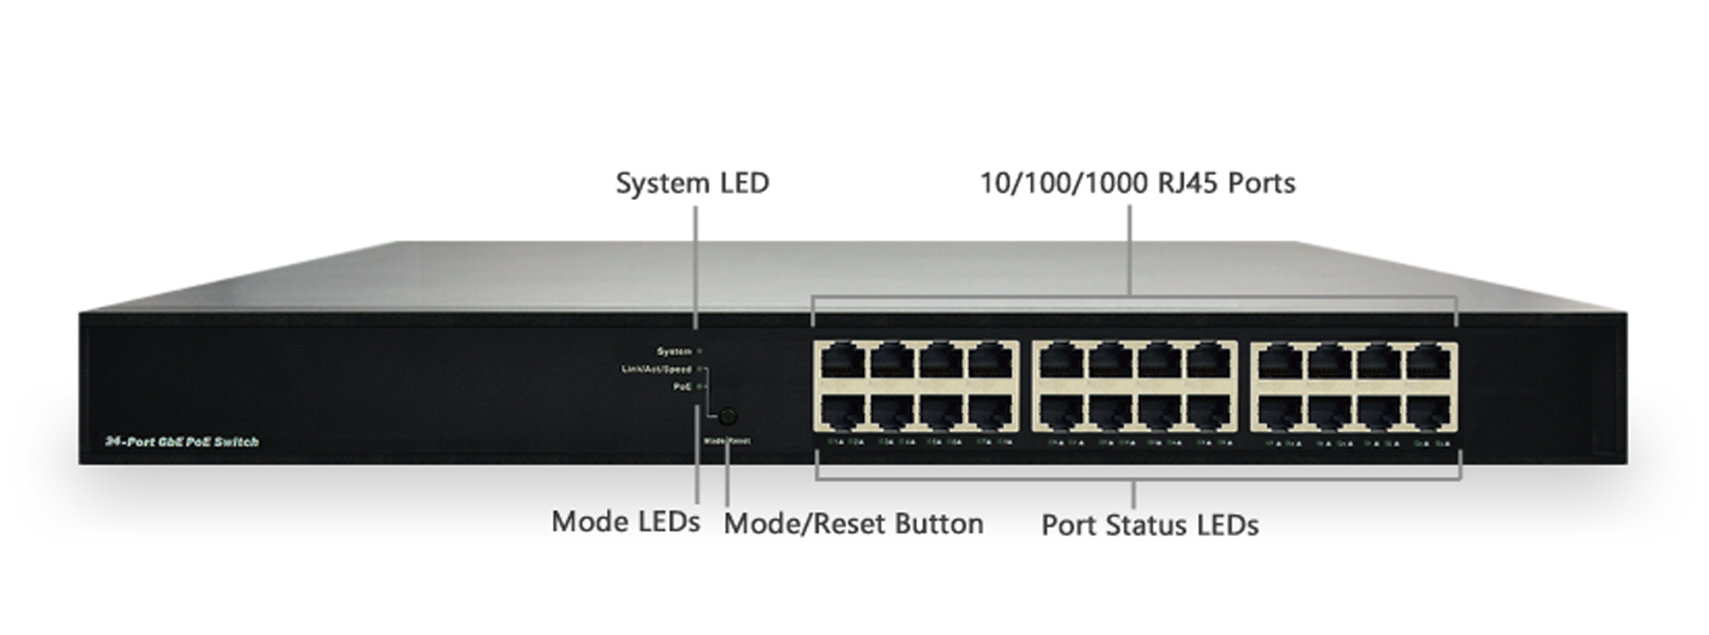

Overview
PSGS-5524F unmanaged GbE PoE+ switch is a plug-and-play Ethernet switch offering easy way to make the transition to Gigabit Ethernet and increase the speed of your network connection. The energy efficient, built to last, and rigorously tested provide the reliability businesses need.
PSGS-5524F delivers 24 (10M/100M/1G) RJ45 with 24 PoE+ (Support 802.3 at/af, and total up to 370W) ports. PSGS-5524F provides high HW performance and environment flexibility for SMBs and Enterprises.

Key Features
- IEEE 802.3u 100BASE-TX, 100Base-FX Fast Ethernet
- IEEE 802.3ab 1000Base-T Gigabit Ethernet
- IEEE 802.3z 1000Base-X Gigabit Fiber Ethernet
- IEEE 802.3az EEE Energy Efficient Ethernet standard for green Ethernet
- IEEE 802.3af/at Power over Ethernet

Benefits
- Lowing Total Cost of Ownership (TCO) with Energy-efficient Design
The switch is designed to help companies to save power needs and reduce TCO by Energy Efficient Ethernet (IEEE 802.3az). It can be used for customers to build a green Ethernet networking environment.

- Advanced Power over Ethernet Management
The model includes PoE+ options to power IP devices with power-saving features like Power scheduling and PoE configuration.

Specifications
Port Configuration
Total Ports | RJ45 (10M/100M/1G) | Uplinks (100M/1G) | Console
24 | 24 | -- | --

Hardware Performance
Forwarding Capacity (Mpps) | Switching  Capacity (Gbps) | Mac Table  (K) | Jumbo Frames  (Bytes)
35.712 | 48 | 8 | 9216

Environmental Range
Operating Temperature |  | Storage Temperature |  | Operating Humidity | Altitude
Fahrenheit | Centigrade | Fahrenheit | Centigrade | 10% to 90% non-condensing | Feet | Meters
32 to 122 | 0 to 50 | -4 to 158 | -20 to 70 | 10% to 90% non-condensing | < 10000 | <3000

Dimension, Weights, Mounting
Dimension (WxHxD) |  |  |  | Weight |  |  |  | Mounting Type
Millimeter |  | Inches |  | Kilograms |  | Pounds |  | Mounting Type
442x 44x 211 | 17.4x 1.7x 8.3 |  | <3 |  | <6.6 |  | Desktop, Rack

Voltage and Frequency
AC Input Voltage and Frequency
Voltage | 100-240 VAC
Frequency | 50~60 Hz

PoE Power Capacity
Available PoE Power | Number of Ports That Support PoE(15.4W) and PoE+(30.0W)
370W | Each of port 1 - 24 support PoE/ PoE+ within available PoE Power

Certifications
Electromagnetic Emissions (EMC)
CE, FCC Part 15 Class A

