PSGS-6552XBF L2+ Managed GbE PoE+ SDN Switch
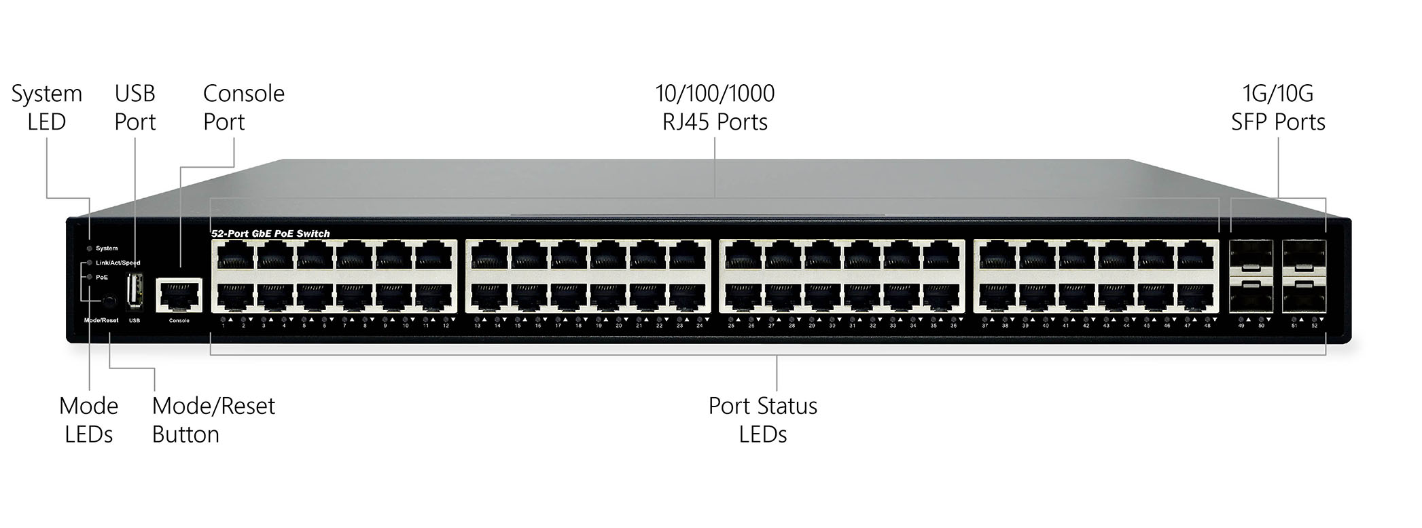
Overview
PSGS-6552XBF L2+ Managed PoE+ SDN Switch is an innovative SDN/Legacy hybrid mode switch, which is capable of running full suite of L2 features, including basic L3 features such as DHCP Server, better PoE functionality and usability that delivers better cost performance and lower total cost of ownership in Enterprise networks via fiber or copper connections, and at the same time, provides next-generation SDN functions to the network. By collaborating with Network Controller, PSGS-6552XBF can provide efficient SDN networking management functions and dynamic resource adjustment functions to the network, which makes it suitable for those networks that require efficient management tools and flexible resource re-assignment in short time, e.g., IoT networks and smart city /school infrastructure networks.
PSGS-6552XBF is Software Defined Networking (SDN) ready and is able to support OpenFlow v1.3. It is suitable for networks from a small workgroup to a large business either as edge devices in an SDN or be standalone since Hybrid Mode is supported.
PSGS-6552XBF delivers 48 (10M/100M/1G) RJ45 with 48 PoE+ ports (support 802.3 at/af and total up to 760W), 4 SFP+ ports, 1 USB port, and RJ45 console port. PSGS-6552XBF provides high HW performance and environment flexibility for SMBs and Enterprises.
Key Features
- SDN OpenFlow v1.3 (support Hybrid Mode)
- L2+ Managed features provide easier manageability, robust security and QoS.
- Support Secure boot function (option by request)
- IPv4/IPv6 Management
- PoE Port configuration and scheduling
- 802.3at high power PoE plus standard
- IEEE 802.3az EEE Energy Efficient Ethernet standard for green Ethernet
- ITU-T G.8032 Ethernet Ring Protection Switching (ERPS) (to be launched by 2022)
Benefits
- Software Defined Networking (SDN)
OpenFlow v1.3 is a key technology that enables the use of SDN to build smart applications that unlock value and reduce cost. OpenFlow v1.3 support encryption, connection interruption and inactivity probe. It can be managed by any OpenFlow-based SDN Controller, and support hybrid pipeline for legacy L2 features at the same time for more enterprise applications. OpenFlow-hybrid switches support both OpenFlow operation and normal Ethernet switching operation.

- Feature-rich Ethernet Switch for Enterprise-class
The switch delivers advanced functionality in L2+ managed switch. It also has comprehensive security features such as IP source guard and ACL to guard your network from unauthorized access. It helps users to build on the market-leading price/performance with L2+ Managed GbE PoE switch, and provide secure, reliable and ease of use for enterprise/SMB deployments.

- Energy-efficient Design
It is designed to help customers to reduce power consumption and lower the TCO by Energy Efficient Ethernet (IEEE 802.3az) features. It can be used for customers to build a green Ethernet networking environment.

- Advanced Power over Ethernet Management
The model includes PoE+ options to power IP devices with power-saving features like Power scheduling and PoE configuration.
Specifications
Port Configuration
Total Ports | RJ45 (10M/100M/1G) | Uplinks (1/10G) | Console
52 | 48 | 4 SFP+ | RJ45

Hardware Performance
Forwarding Capacity (Mpps) | Switching  Capacity (Gbps) | Mac Table  (K) | Jumbo Frames  (Bytes)
130.944 | 176 | 32 | 12K

Environmental Range
Operating Temperature |  | Storage Temperature |  | Operating Humidity | Altitude
Fahrenheit | Centigrade | Fahrenheit | Centigrade | 10% to 90% non-condensing | Feet | Meters
32 to 122 | 0 to 50 | -4 to 158 | -20 to 70 | 10% to 90% non-condensing | < 10000 | <3000

Dimension, Weights, Mounting
Dimension (WxHxD) |  | Weight |  | Mounting Type
Millimeter | Inches | Kilograms | Pounds | Mounting Type
442x 44x 375 | 17.4x 1.7x 14.8 | <5.62 | <12.39 | Desktop, Rack

Voltage and Frequency
AC Input Voltage and Frequency
Voltage | 100-240 VAC | Frequency | 50~60 Hz
PoE Power Capacity
Available PoE Power | Number of Ports That Support PoE(15.4W) and PoE+(30.0W)
760W | Each of port 1 - 48 support PoE/ PoE+ within available PoE Power

Certifications
Electromagnetic Emissions (EMC)
EN61000-4-2, EN61000-4-3, EN61000-4-6, EN61000-4-4, EN61000-4-5
CE, FCC Part 15 Class A, LVD (UL by request)

Software Features
SDN OpenFlow Features
Version |  | V1.3
Hybrid Mode |  | Support
Classification Mechanism |  | Port/VLAN/Port+Vlan
Pipeline Traversal |  | - OpenFlow pipeline  - Traditional pipeline
Entry Table |  | 32K
Flow Table Stage |  | 5 (3 Full Match+ L2 Optimized+ L3 Optimized, Loopback extensible)
Entry Capability |  | - Operation  - Hit Flag
Metadata Match |  | Support
Group Table |  | - 2K Group Entries  - 8K Action Buckets
Meter Table |  | - 512 policer  - Drop
Counter |  | - 4K 32-bit packet counter  - 4K 64-bit byte counter
Layer 2 Switching
Spanning Tree Protocol (STP) |  | - Standard Spanning Tree 802.1d  - Rapid Spanning Tree (RSTP) 802.1w  - Multiple Spanning Tree (MSTP) 802.1s  - BPDU Guard  - STP Root Guard
Trunking |  | Link Aggregation Control Protocol (LACP) IEEE 802.3ad  - Up to 26 groups  - Up to 16 ports per group
VLAN |  | Supports up to 4K VLANs simultaneously (out of 4096 VLAN IDs)  - Port-based VLAN  - 802.1Q tag-based VLAN  - MAC-based VLAN  - Management VLAN  - Private VLAN  - Guest VLAN  - Voice VLAN  - 802.1v Protocol VLAN  - IP Subnet-Based VLAN
GARP VLAN Registration Protocol (GVRP) |  | GVRP stands for GARP (Generic Attribute Registration Protocol) VLAN Registration Protocol. It’s a Layer 2 network protocol, for automatic configuration of switches in a VLAN network
IGMP v1/v2/v3 Snooping |  | IGMP limits bandwidth-intensive multicast traffic to only the requesters. Supports 1024 multicast groups
MLD v1/v2 Snooping |  | Delivers IPv6 multicast packets only to the required receivers
Multicast VLAN Registration (MVR) |  | It uses a dedicated manually configured VLAN, called the multicast VLAN, to forward multicast traffic over Layer 2 network in conjunction with IGMP snooping.
L3 Features
DHCP Server | Support DHCP server to assign IP to DHCP clients (to be launched by 2022)
Security
Secure Shell (SSH) |  | SSH secures Telnet traffic in or out of the switch, SSH v1 and v2 are supported
Secure Sockets Layer (SSL) |  | SSL encrypts the http traffic, allowing advanced secure access to the browser-based management GUI in the switch
IEEE 802.1X |  | - IEEE802.1X: RADIUS authentication, authorization and accounting, MD5 hash, guest VLAN, single/multiple host mode and single/multiple sessions  - Dynamic VLAN assignment
Port Security |  | Locks MAC addresses to ports, and limits the number of learned MAC address
TACACS+ |  | Supports TACACS+ authentication.
Storm Control |  | Prevents traffic on a LAN from being disrupted by a broadcast, multicast, or unicast storm on a port
ACLs |  | Supports up to 256 entries. Drop or rate limitation based on:  - Source and destination MAC, VLAN ID or IP address, port
IP Source guard |  | Prevents illegal IP address from accessing to specific port in the switch
DHCP Snooping |  | A feature acts as a firewall between untrusted hosts and trusted DHCP servers
Loop Protection |  | To prevent unknown unicast, broadcast and multicast loops in Layer 2 switching configurations.
DHCP Client |  | Support DHCP server to assign IP to DHCP clients
DHCP Relay (option 66,option 67,option 82) |  | - Relay of DHCP traffic to DHCP server in different VLAN.  - Works with DHCP Option 82
Quality of Service
Hardware Queue |  | Supports 8 hardware queues
Scheduling |  | - Strict priority and weighted round-robin (WRR)  - Queue assignment based on DSCP and class of service
Classification |  | - Port based  - 802.1p VLAN priority based  - IPv4/IPv6 precedence / DSCP based  - Classification and re-marking TCP/IP ACLs: QoS by ACL
Rate Limiting |  | - Ingress policer  - Egress shaping and rate control
Management
Remote Monitoring (RMON) |  | Embedded RMON agent supports RMON groups 1,2,3,9 (history, statistics, alarms, and events) for enhanced traffic management, monitoring and analysis
Port Mirroring |  | Traffic on a port can be mirrored to another port for analysis with a network analyzer or RMON probe. Up to N-1 (N is Switch’s Ports) ports can be mirrored to single destination port. A single session is supported.
Web GUI Interface |  | Built-in switch configuration utility for browser-based device configuration
CLI/ Telnet |  | For users to configure/manage switches in command line modes
Dual Image |  | Independent primary and secondary images for backup while upgrading
SNMP |  | SNMP version1, 2c and 3 with support for traps, and SNMP version 3 user-based security model (USM)
Firmware Upgrade |  | - Web browser upgrade (HTTP/ HTTPs) and TFTP, SFTP, and SCP  - Upgrade through console port as well
Syslog |  | Support syslog function
SMTP |  | Support SMTP (RFC821)
IEEE 802.1ab (LLDP) |  | - Used by network devices for advertising their identities, capabilities, and neighbors on an IEEE 802ab local area network  - Support LLDP-MED extensions
CDP Aware |  | The CDP operation is restricted to decoding incoming CDP frames (The switch doesn’t transmit CDP frames). CDP frames are only decoded if LLDP on the port is enabled
sFlow |  | The industry standard for monitoring high speed switched networks. It gives complete visibility into the use of networks enabling performance optimization, accounting/billing for usage, and defense against security threats
NTP |  | Network Time Protocol (NTP) is a networking protocol for clock synchronization between computer systems over packet-switched
Other Management |  | IPv6 Management
Power over Ethernet (PoE)
Port Configuration |  | Supports per port PoE configuration function
PoE Scheduling |  | Supports per port PoE scheduling to turn on/off the PoE devices (PDs).
Auto-checking |  | Check the link status of PDs. Reboot PDs if there is no responses.
Power Delay |  | The switch provides power to the PDs based on delay time when PoE switch boots up, in order to protect switch from misuse of the PDs
Soft-Reboot PoE Non-stop |  | The switch will keep providing power to the PDs while during soft-reboot.

