IGS-5508
Industrial Unmanaged GbE Switch

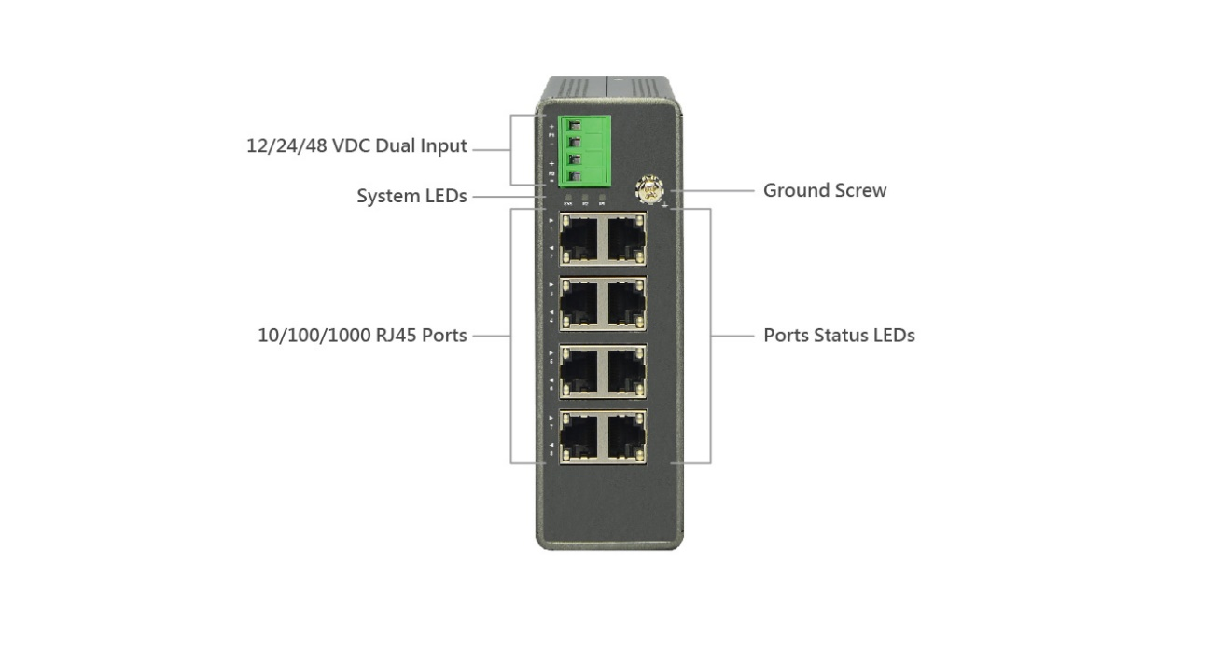

Overview
IGS-5508 industrial unmanaged GbE switch is a plug-and-play Ethernet switches offering easy way to make the transition to Gigabit Ethernet and increase the speed of your network connection. The energy efficient, built to last, and rigorously tested provide the reliability businesses need, of which make them suitable for industrial Ethernet applications.
IGS-5508 delivers 8 (10M/100M/1G) RJ45. IGS-5508 offers users with various options of port combinations, in order to meet different requirements in various applications.
Key Features
- Slim type industrial switch
- IEEE 802.3az Energy Efficient Ethernet standard for green Ethernet application

Benefits
- Lowing Total Cost of Ownership (TCO) with Energy-efficient Design
The switch is designed to help companies to save power needs and reduce TCO by Energy Efficient Ethernet (IEEE 802.3az). It can be used for customers to build a green Ethernet networking environment.
Specifications
Port Configuration
Total Ports | RJ45 (10M/100M/1G) | Uplinks (100M/1G) | Console
8 | 8 | -- | --

Hardware Performance
Forwarding  Capacity (Mpps) | Switching  Capacity (Gbps) | Mac Table  (K) | Jumbo Frames  (Bytes)
11.9 | 16 | 4 | 9216

Environmental Range
Operating Temperature |  | Storage Temperature |  | Operating Humidity | Altitude
Fahrenheit | Centigrade | Fahrenheit | Centigrade | 5% to 95%  non-condensing | Feet | Meters
-40 to 167 | -40 to 75 | -40 to 185 | -40 to 85 | 5% to 95%  non-condensing | <10000 | <3000

Dimension, Weights, Mounting
Dimension (WxHxD) |  |  | Weight |  |  | Mounting Type
Millimeter | Inches |  | Kilograms |  | Pounds
44x 135x 130 | 1.7x 5.3x 5.1 | < 1 |  | <2.2 |  | DIN rail, Wall

Voltage and Frequency
Primary Power Supply - DC Input Voltage
DC Nominal | 12/24/48 VDC dual inputs
DC Operating Range | 12 to 48 VDC

Certifications
Regulatory Compliance
EMS | EN61000-4-2 ESD, EN61000-4-3 RS, EN61000-4-4 EFT, EN61000-4-6 CS, EN61000-4-8 PFMF, (EN61000-6-2 by request)
EMI | FCC Part 15 Class A  (EN61000-3-2, EN61000-3-3, EN61000-6-4, EN55022, EN55011 by request)
Safety | CE, (EN60950 by request)
Mechanical Stability (by request)
Vibration | IEC 60068-2-6
Shock | IEC 60068-2-27
Freefall | IEC 60068-2-32
Approvals (by request)
Railway Norm | EN50121-4, EN50155
Transportation | NEMA TS2
Substation | IEC61850-3, IEEE1613

